Table of Contents

Introduction 2

Navigating Unreal Engine 2

Transforming objects 3

Duplicating Objects 4

Mirroring Objects 4

Azerty Keyboard Layout 6

Changing the skylight HDRI 7

Changing your lighting 8

Importing Assets through Quixel Bridge 9

Engine Performance – lower graphics quality 10

Setting up your Camera Viewpoint 11

Piloting the camera 11

Locking and unlocking the camera movement 12

Colour Correction on MegaScans Assets 13

Vertex Painting: dealing with large blocks with obvious repetitive details 14

Sharing ‘Merged Assets’ 21

Landscape Sculpting 27

# Introduction

All keyboard shortcuts assume QWERTY layout. But, for Azerty, using the provided AZERTY keyboard layout, the shortcuts have been remapped to the same physical locations on the keyboard, A -> Q, Q -> A, etc… So we always use the top row of keys for transformation actions:

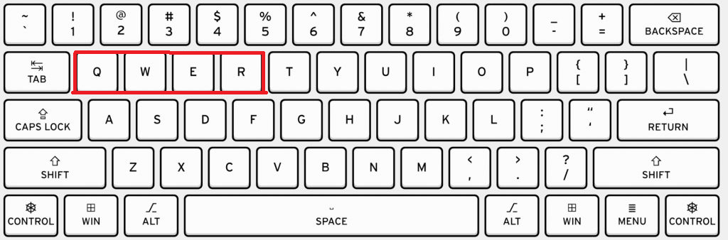

And the following keys for navigation actions:

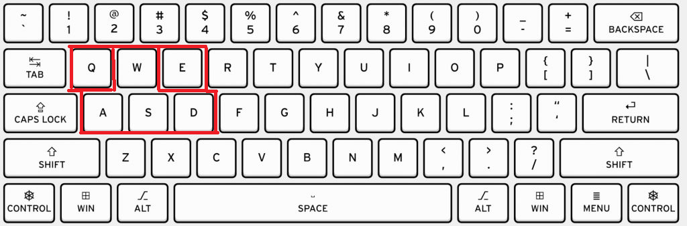

# Navigating Unreal Engine

Navigation in unreal engine is relatively straightforward for those somewhat familiar with games.

* WASD while holding RMB moves the camera forward/left/backward/right
* QE while holding RMB moves the camera down/up respectively
* Scrolling while holding RMB changes the camera speed
* Scrolling without RMB moves camera forward/backward

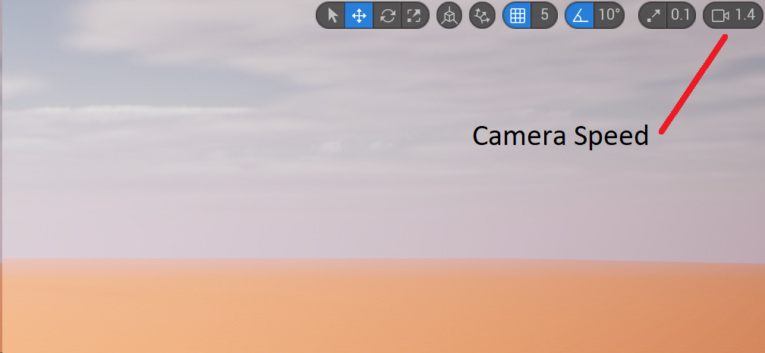

# Transforming objects

You can move (translate), rotate and scale objects easily. There are shortcuts for this as well as buttons you can click. **Without holding RMB**:

* Q: select object mode
* W: translation/move mode
* E: rotation mode
* R: scaling mode

All transformations (translation/rotation/scaling) can be snapped in increments or free. Snapping can use the grid (translation), or rotate in increments of a fixed number of degrees (e.g. 10 degrees, 30 degrees, …, 90 degrees, …) or scaled in steps.

Clicking the snapping mode for the particular transformation type enables/disables snapping for that transformation.

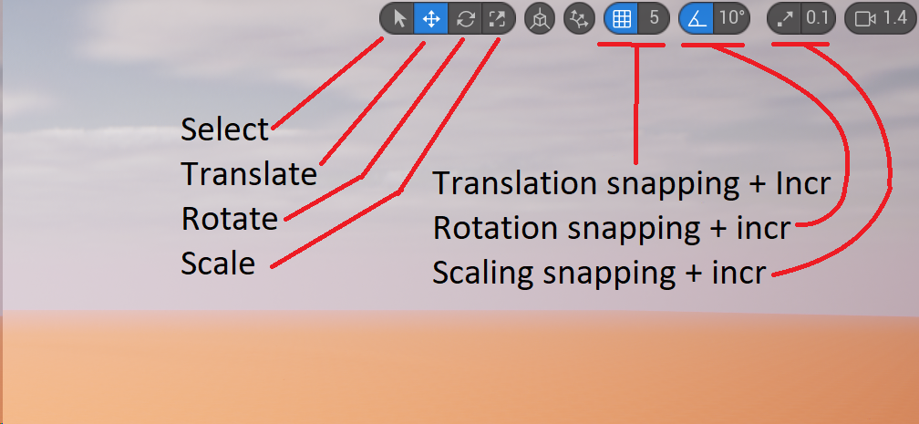

# Duplicating Objects

To duplicate selected objects, select the objects you wish to duplicate, then while holding the **alt** key, **move/rotate/scale** the selected objects and they will be duplicated during the transformation.

# Mirroring Objects

Sometimes you built one half of a structure, and you want to duplicate and mirror the other half. In that case, first duplicate the assets, then right click the selection, and select mirror, with the corresponding axes. The RED axis is X, Green is Y, and blue is Z in general.

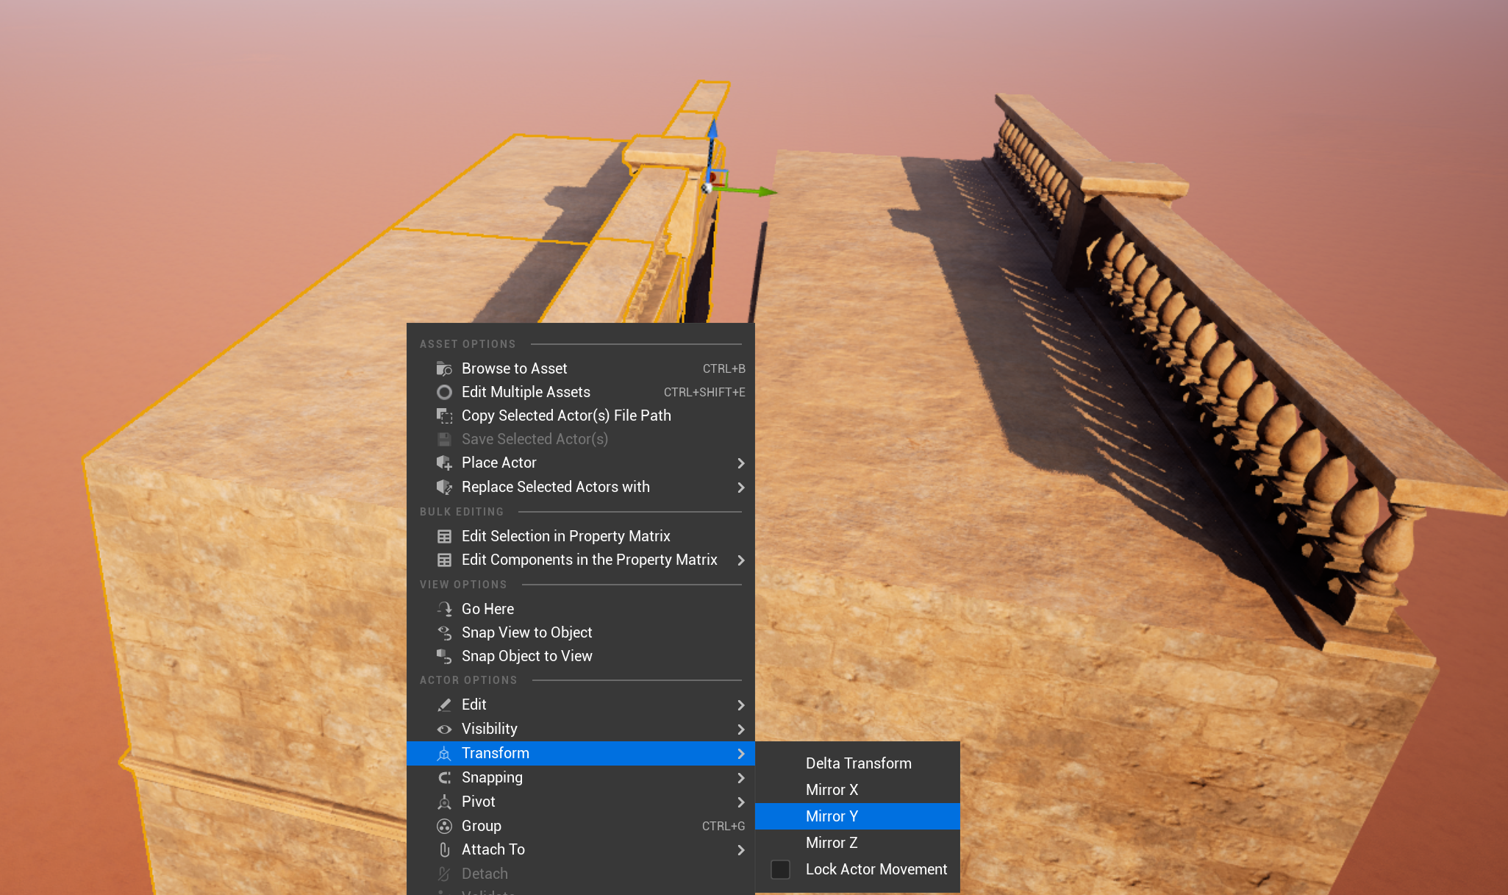

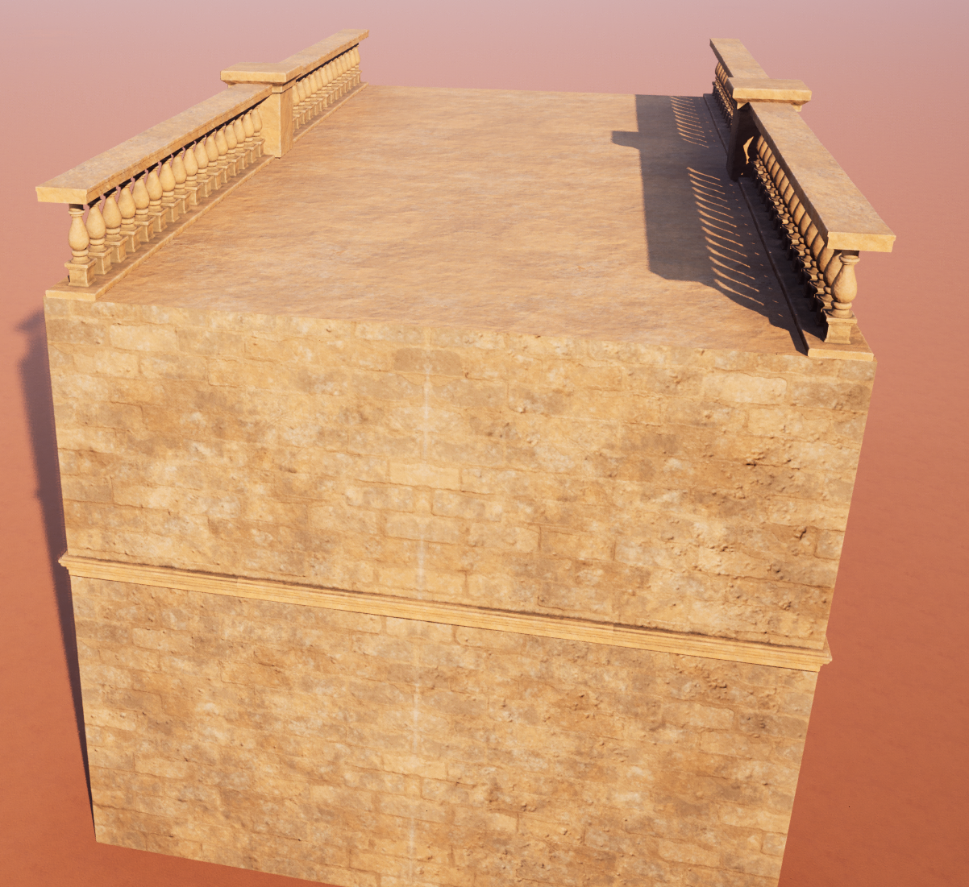

# Azerty Keyboard Layout

If you use an AZERTY keyboard, you should change the default keyboard bindings to work with the AZERTY layout instead of the default QWERTY layout. A preconfigured keyboard layout has been made available to you to import at:

…\ENV_LargeRomanTempleTemplate\Sourcefiles\UNREAL\Grand_Roman_Env\Config

Go to the keyboard shortcuts window and import the provided layout:

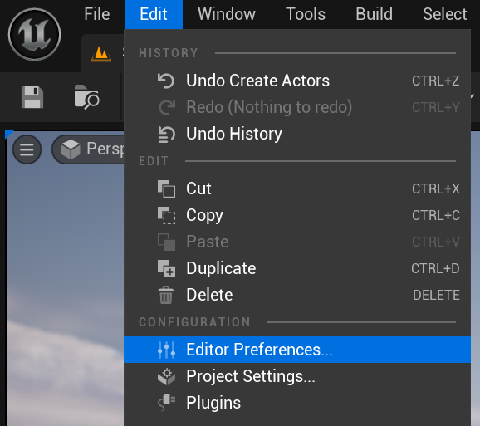

Under section General > Keyboard shortcuts, select the “import” button.

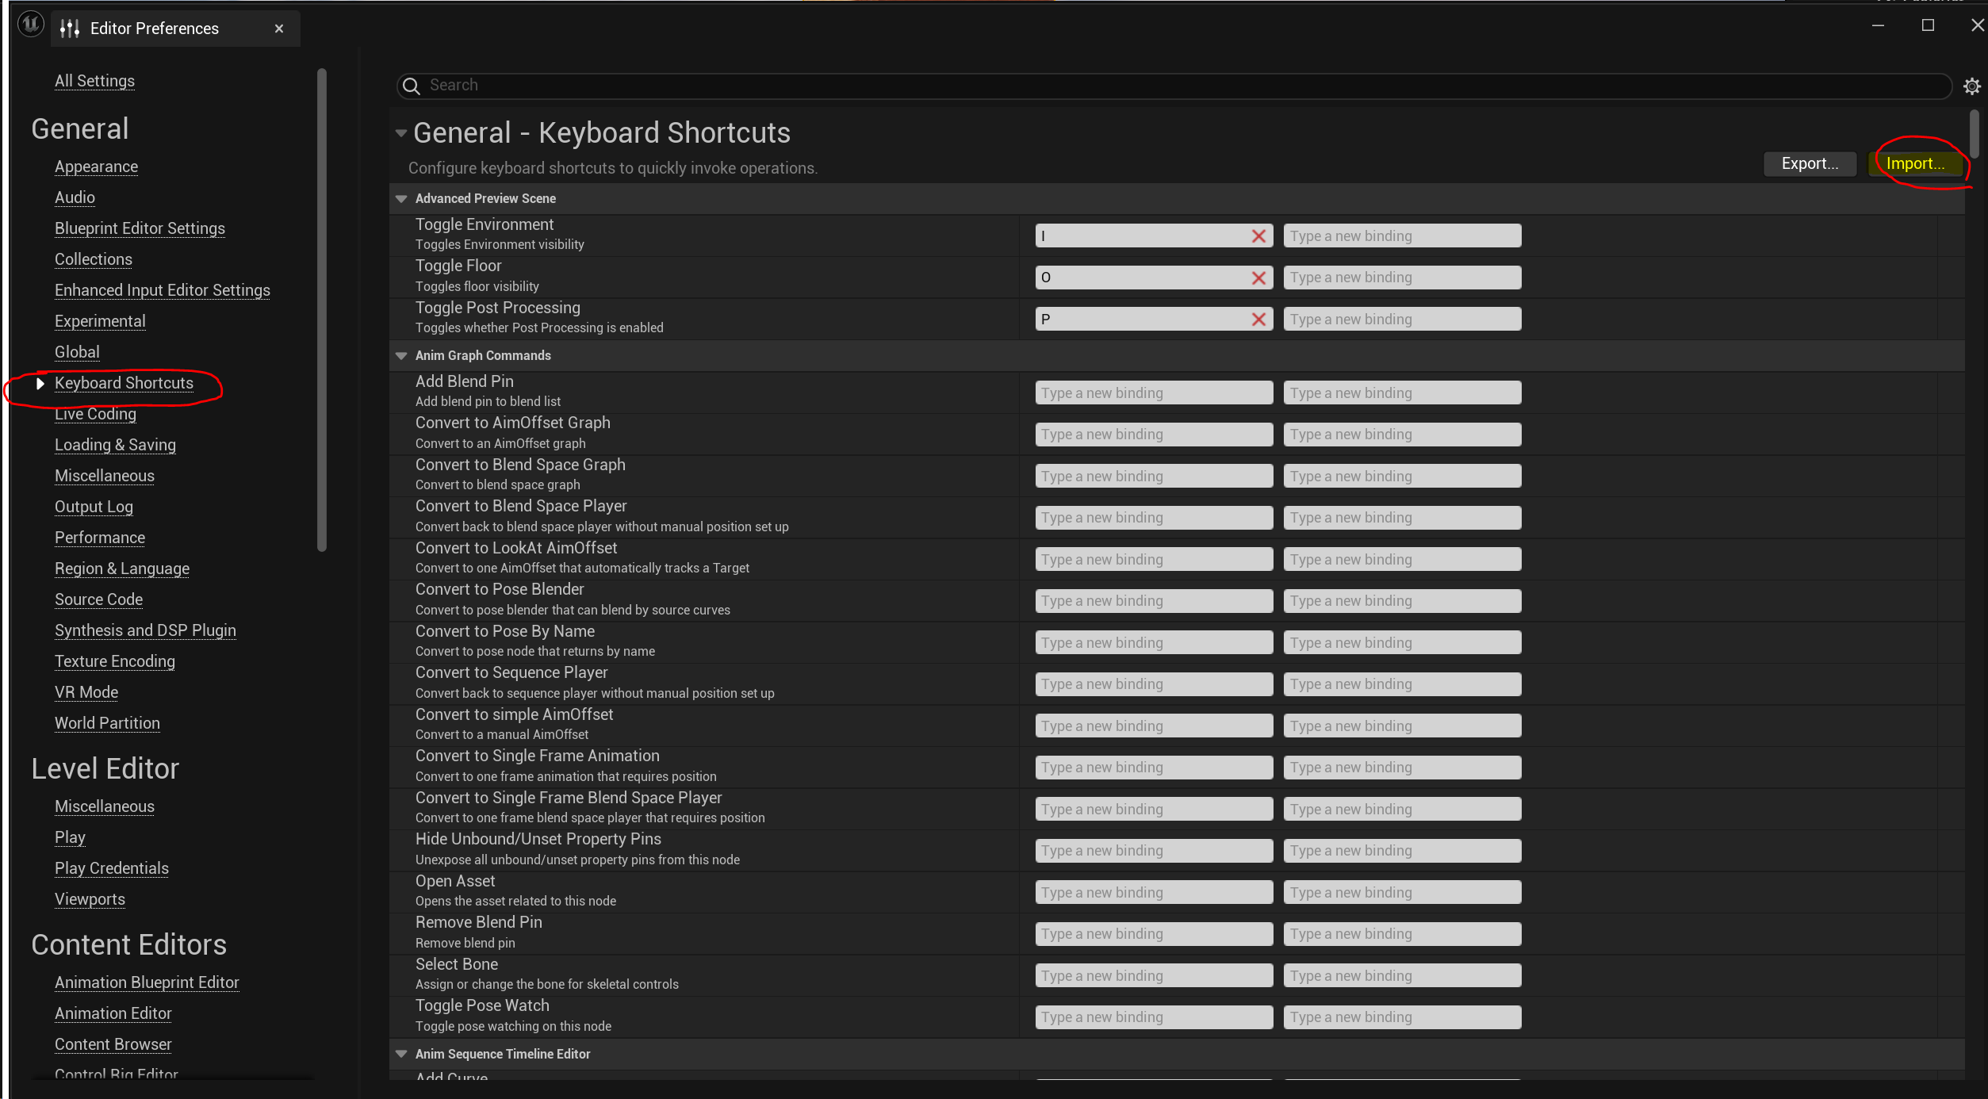

In the dialog, go up one folder to the Config folder, there you will find an AzertyKeyboardShortcuts.ini and QwertyKeyboardShortcuts.ini file. Select the AzertyKeyboardShortcuts.ini file, press okay and restart Unreal Engine as prompted.

# Changing the skylight HDRI

An HDRI provides some coloured lighting to your environment based on a spherical picture that is projected on the world around you. Mostly this affects the atmosphere of your lighting.

HDRI stands for High Dynamic Range Image and are images with a high degree of light intensity and light colour information. Applying a new HDRI to your Skylight can change the atmosphere of your scene.

A number of HDRI images are provided for you to play around with. In the ContentBrowser > Roman_Environment > Textures > HDRI you can find the provided HDRI images. If you want another HDRI image, many HDRI images can be downloaded for free from <https://polyhaven.com>

To change the HDRI used in your level select your Skylight (in the Lights) folder in the outliner of unreal engine (top right corner). Drag the HDRI you wish to use onto the “Cubemap” property.

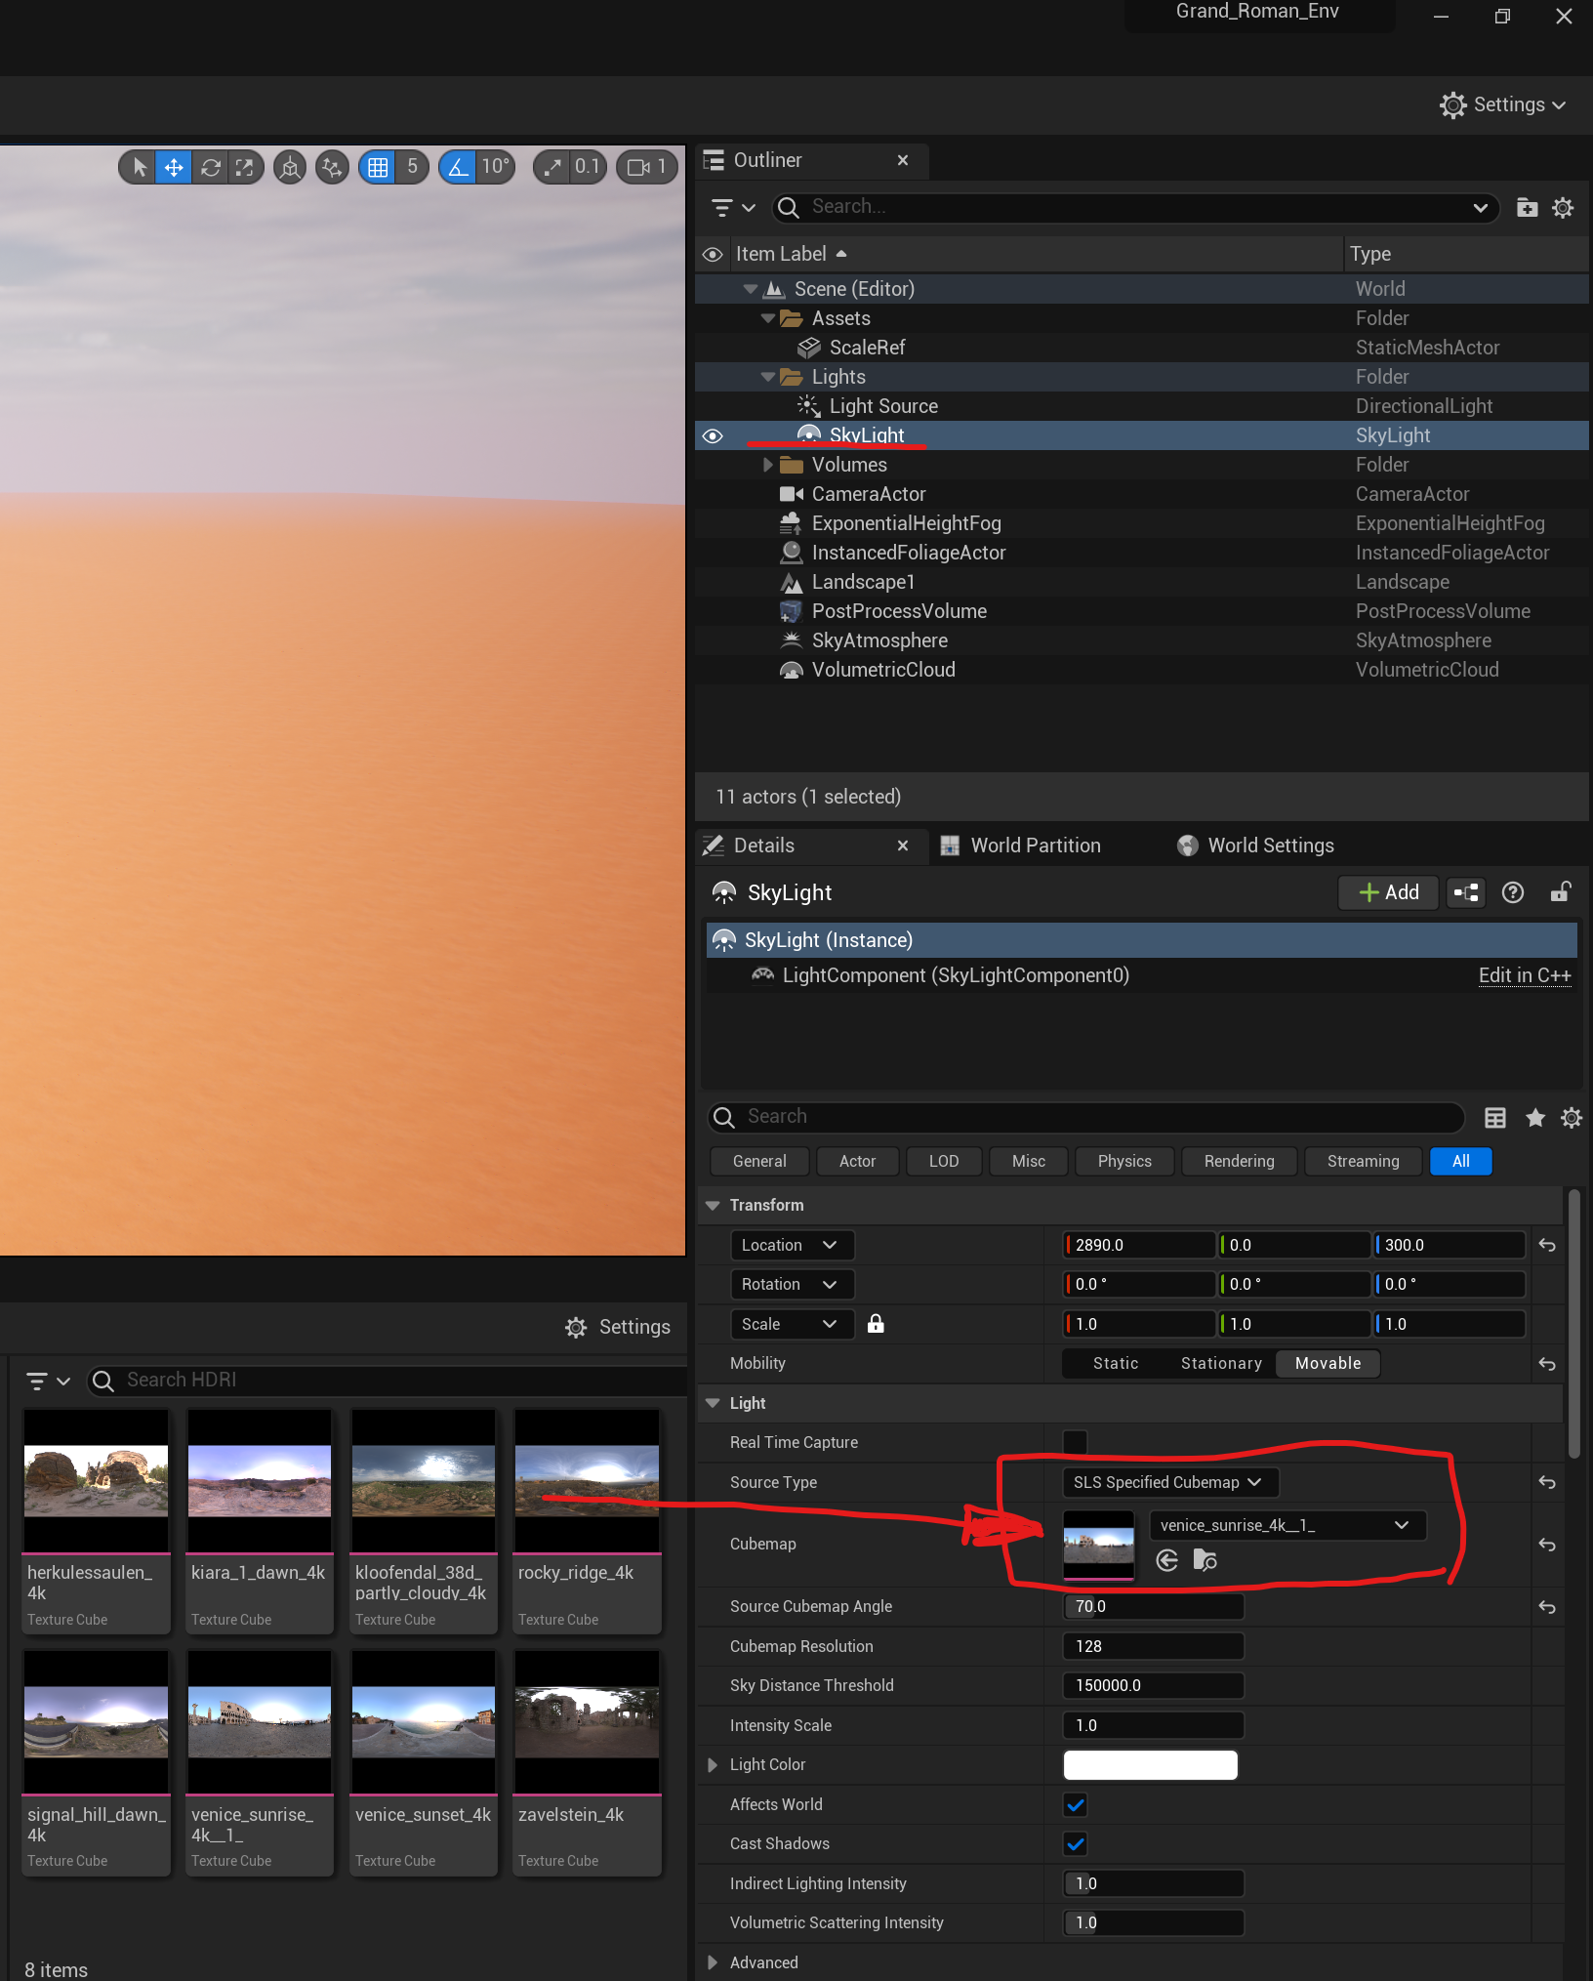

# Changing your lighting

The scene comes with two lights preset. One is the skylight, which is handled in the HDRI section, and the other is the “Light Source” which is a **Directional Light**. The directional light determines where the sun is coming from in your scene, and rotating this object will alter how the shadows fall. Use this to choose a direction which suits your scene and atmosphere.

# Importing Assets through Quixel Bridge

Open the quixel bridge addon and login to your Epic Games account.

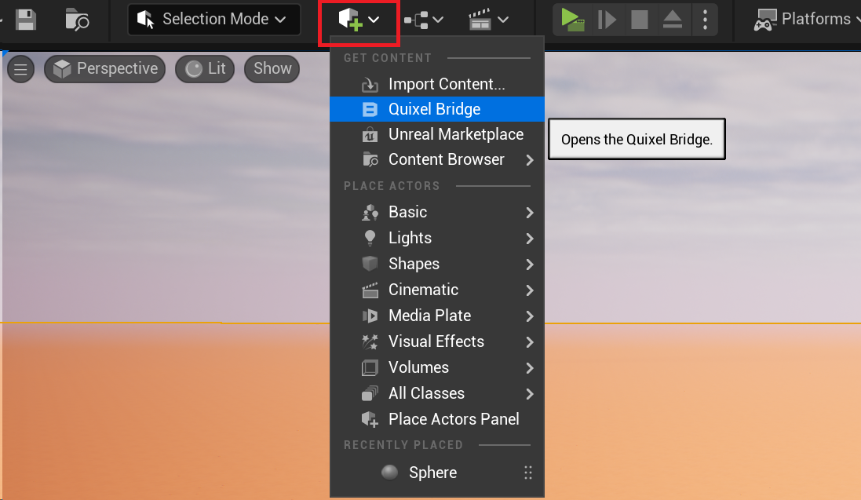

Search Quixel Bridge for an asset of interest, then download the asset and add it to the project.

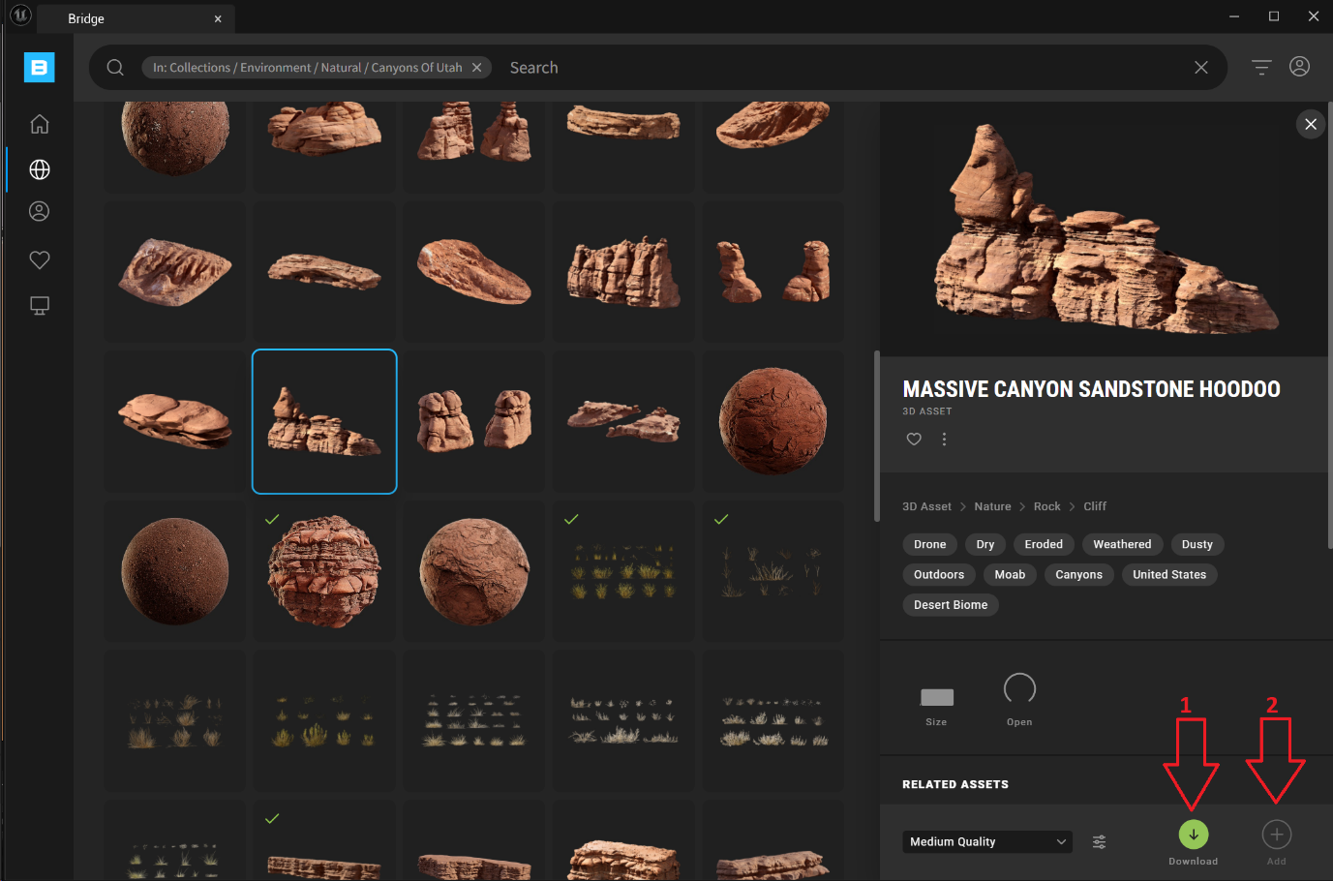

The asset is added to your project under the Content > Megascans folder. The 3D_Assets subfolder will contain the assets, unless you downloaded a material or foliage, in which case you must look in the “Surfaces” or “3D_Plants” folder respectively.

For 3D_Assets you will find a “Static Mesh” object in the folder, which you can drag & drop into your scene.

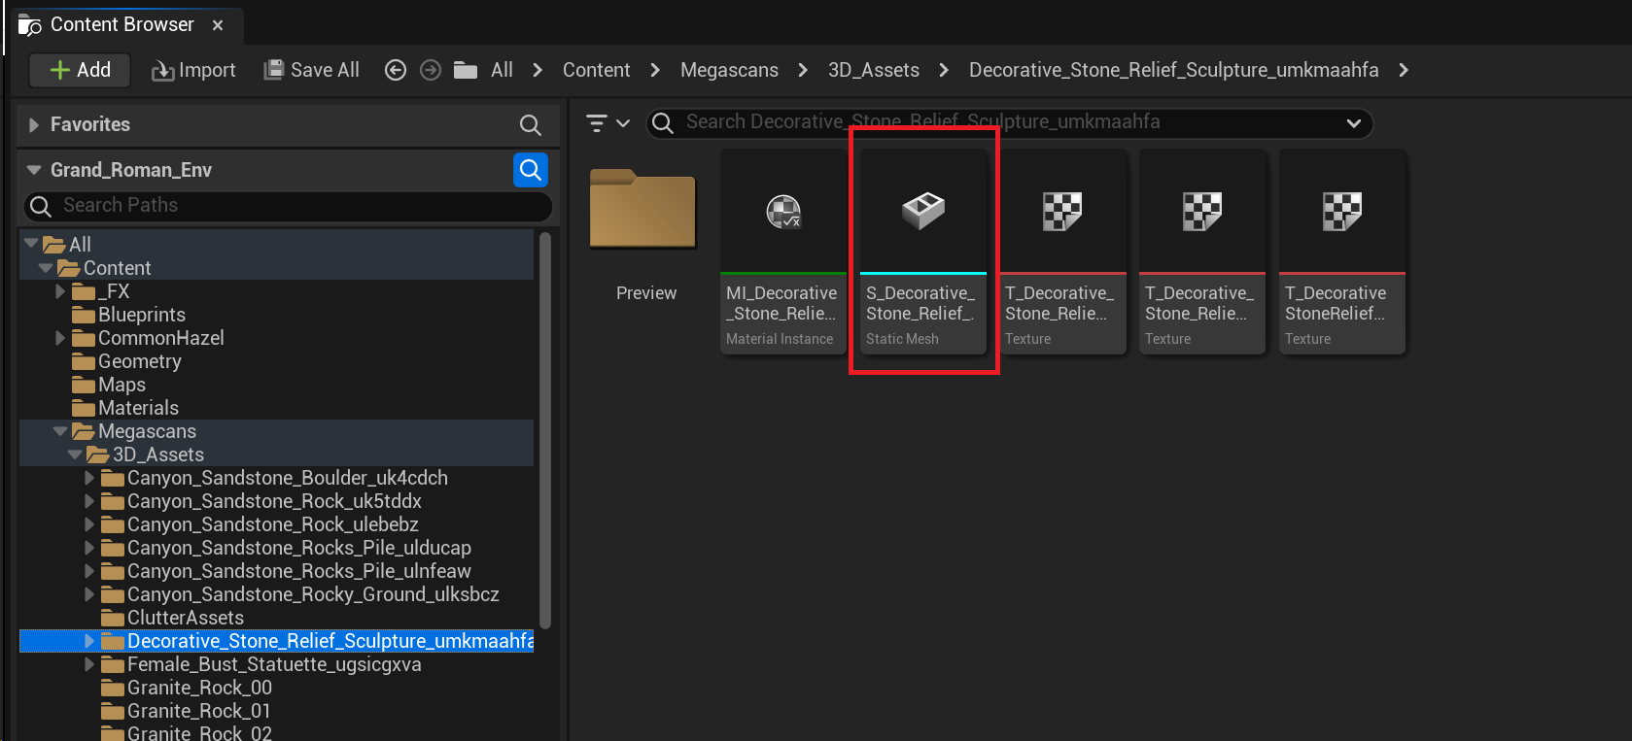

# Engine Performance – lower graphics quality

In top right corner: Settings > Engine Scalability Settings, change quality to Medium / High / Epic, depending on what runs smoothly.

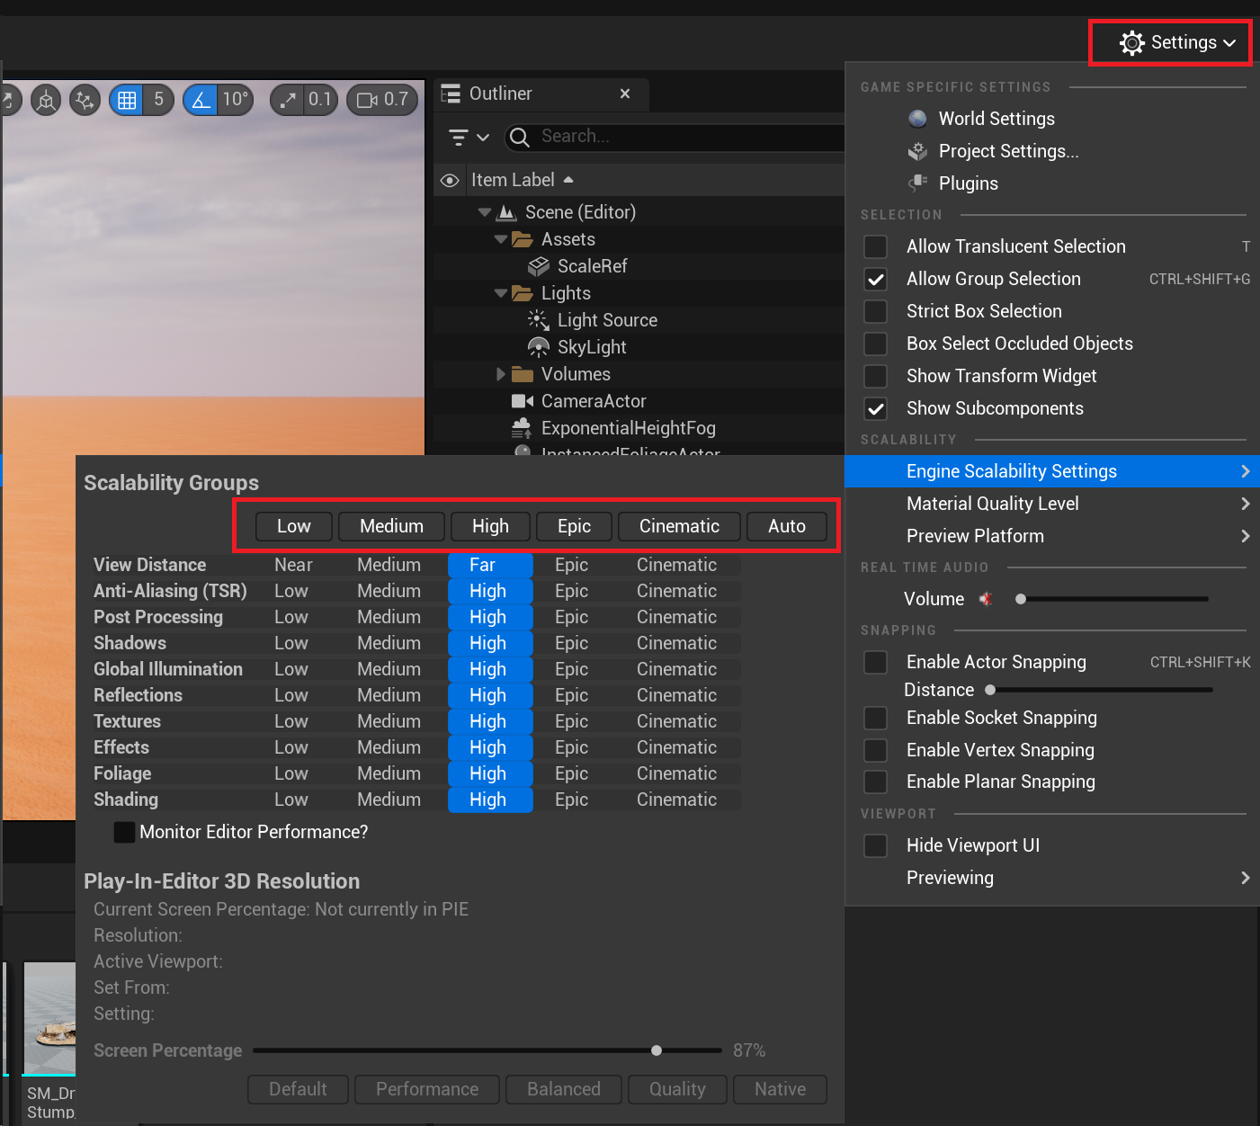

# Setting up your Camera Viewpoint

As specified in the presentation, we will be building a single camera viewpoint environment to reduce the scope of the work we need to do. The camera has been created in your default level.

The camera can be found in the **outliner** > **Cameras** as **CameraActor**.

## Piloting the camera

To pilot the camera, select it from the views in the scene editor:

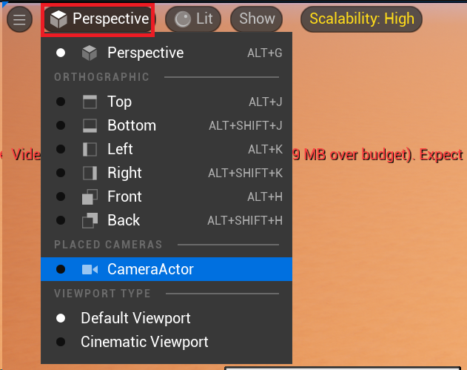

When viewing through the camera. If the camera is not locked, you can move it using the normal navigation shortcuts (WASD). When you are done moving the camera, or want to exit the camera view, you may press the eject button to exit the camera view.

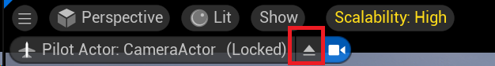

When the camera is locked it cannot be moved.

## Locking and unlocking the camera movement

Locking the camera is a good way to make sure you do not accidentally move your viewpoint after you’ve chosen a good camera angle. To lock the camera, we go through the **outliner**, select the **CameraActor,** right click, and under **Transform** select **Lock Actor Movement.**

Unlocking uses the same menu, but you disable “Lock Actor Movement”.

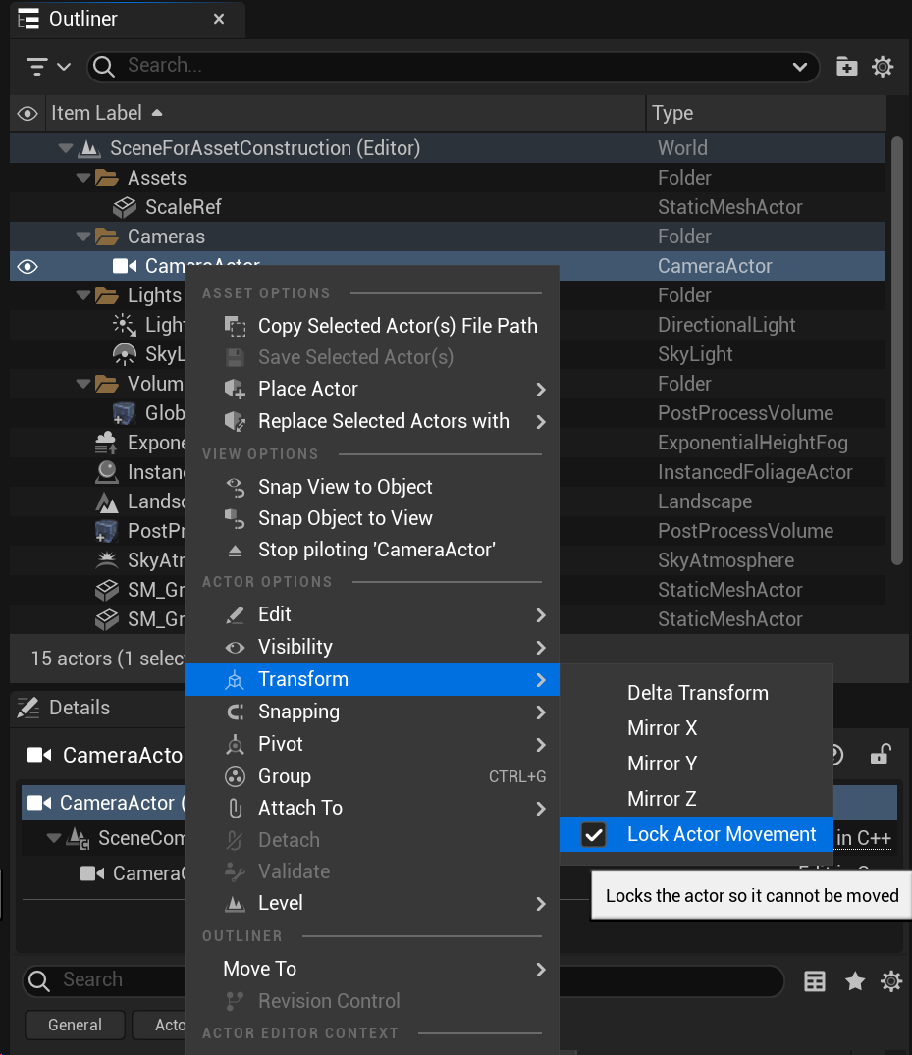

# Colour Correction on MegaScans Assets

Our modular assets (Greek/roman styled) have a rather red sandstone look. This is in line with the concept art reference. However, many assets we can use from Quixel MegaScans will not have this sandstone look. Therefore if we wish to use MegaScans and make sure they don’t clash with our other environment assets, we have to tweak our colours.

To colour correct the MegaScans assets we use the **Albedo Tint** material property of the assets. Select the mesh you wish to alter, double click its material, in the material window (which can be undocked from the tabbed view), activate **Albedo Tint**, click the colour and choose an appropriate tint colour from the colour picker until the asset matches the aesthetic you are going for.

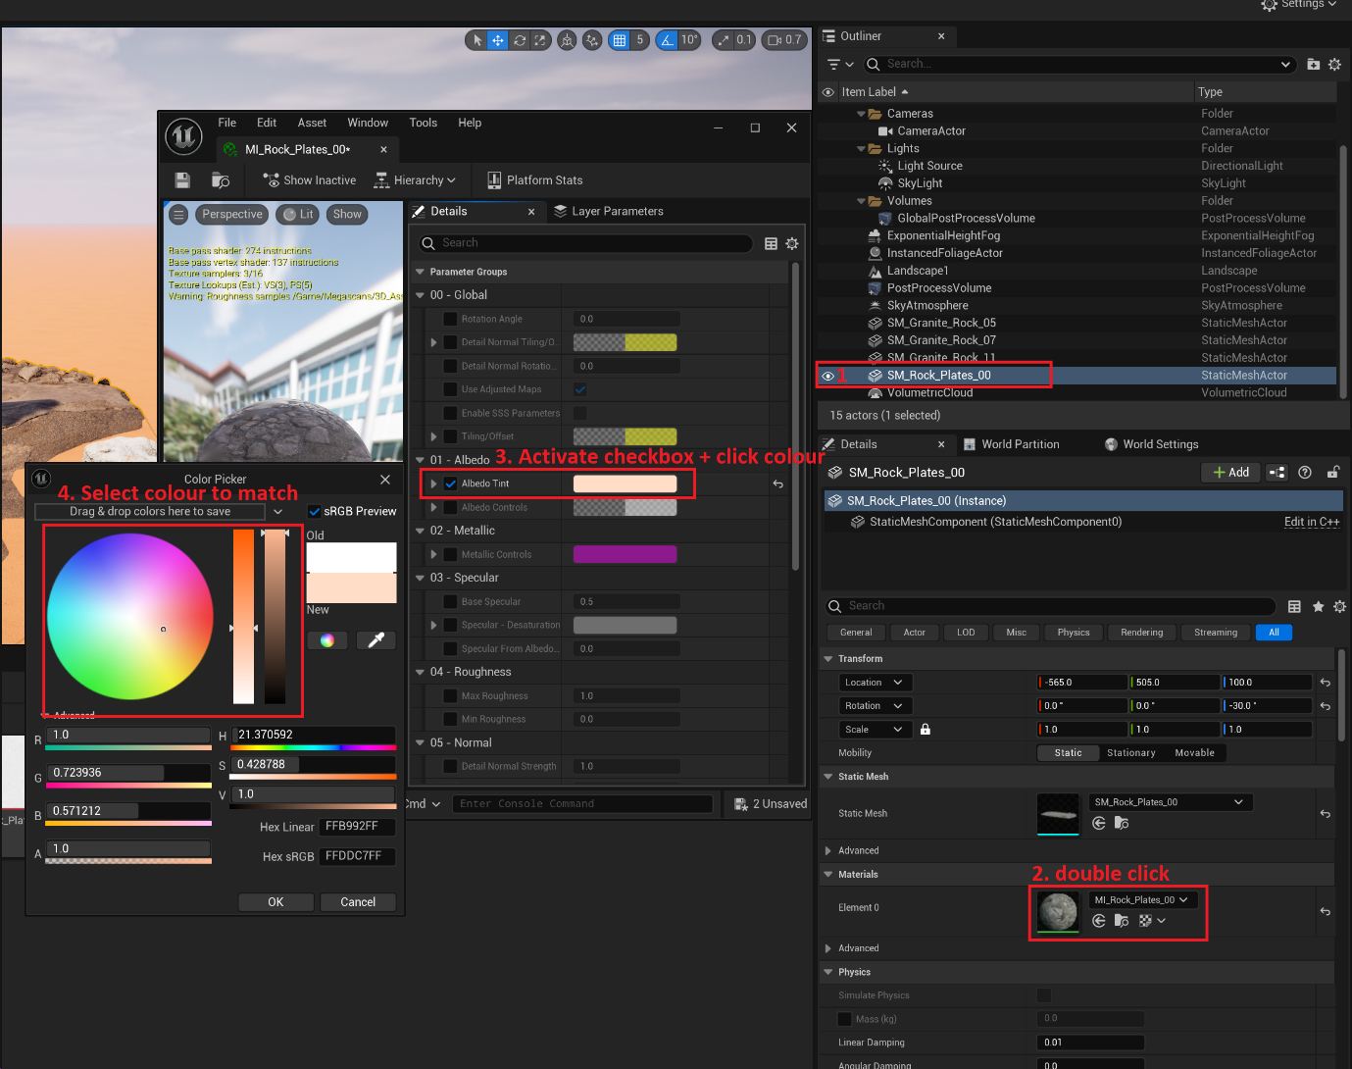

# Vertex Painting: dealing with large blocks with obvious repetitive details

In some cases you will build a large wall, or cube somewhere and throw on a **Tri-Planar Wall aterial** to make it fit with the environment, without it needing a lot of detail. However, it might become very obvious that there is repetitive detail on the large cube. We can deal with this by using the “**Default_Cube_HP**” mesh from the **Roman_Environment > Assets** folder, enabling vertex painting for its material, and vertex painting in the different materials to break the repetition.

Take a look at the cube below:

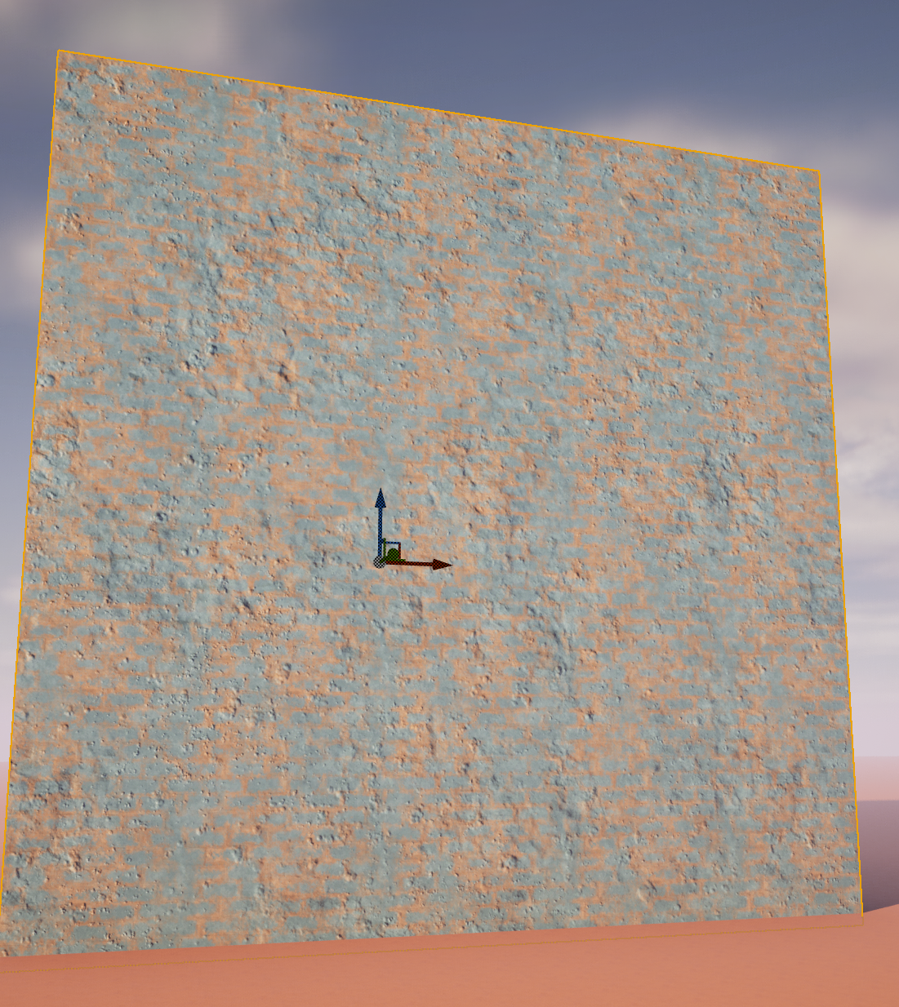

It has clear repetitive detail, or more precisely “Visible tiling of the texture”. To combat this, the ‘tri-planar’ material, as well as many of the other modular asset materials has the ability to use “vertex painting” to blend between three different, well matching materials and fight the visible tiling.

First steps:

* We select the material
* Enable “vertex colours”

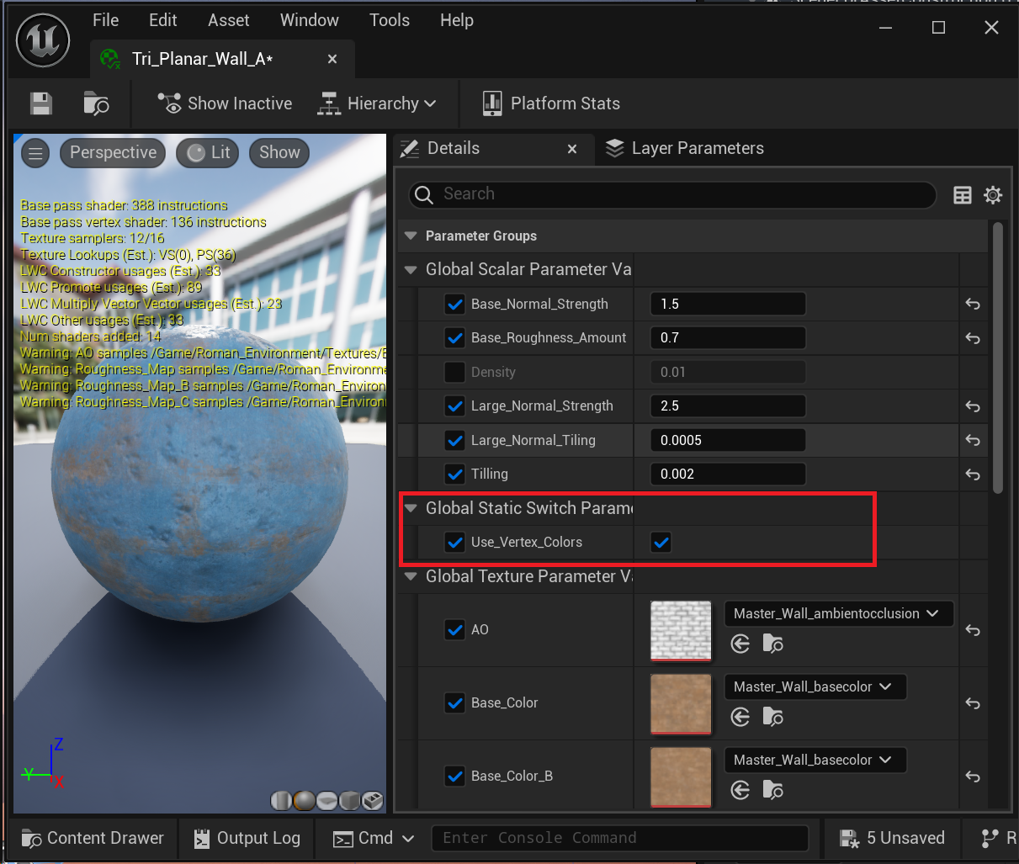

Next we go into “Mesh Paint Mode”.

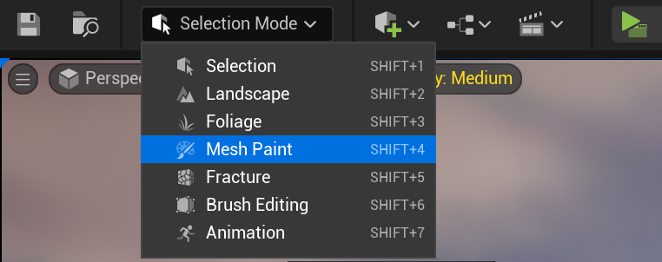

**Note that mesh painting only works on objects that are currently selected**

Mesh painting works as follows. We have 3 alternate wall textures for our Tri Planar Wall material. The base wall, a variation on the base wall, and a variation with faded blue paint.

Controlling which material is used is done by painting in 1’s and 0’s in the red and green channel of the vertices of the mesh. A 1 in the green channel will signify selecting the faded blue variation of the wall. A 1 in the red channel will take non-blue variation 1, and 0’s in both red and green channels will signify selection of the second non-blue variation of the wall.

Start by looking at the values in the red and green channels:

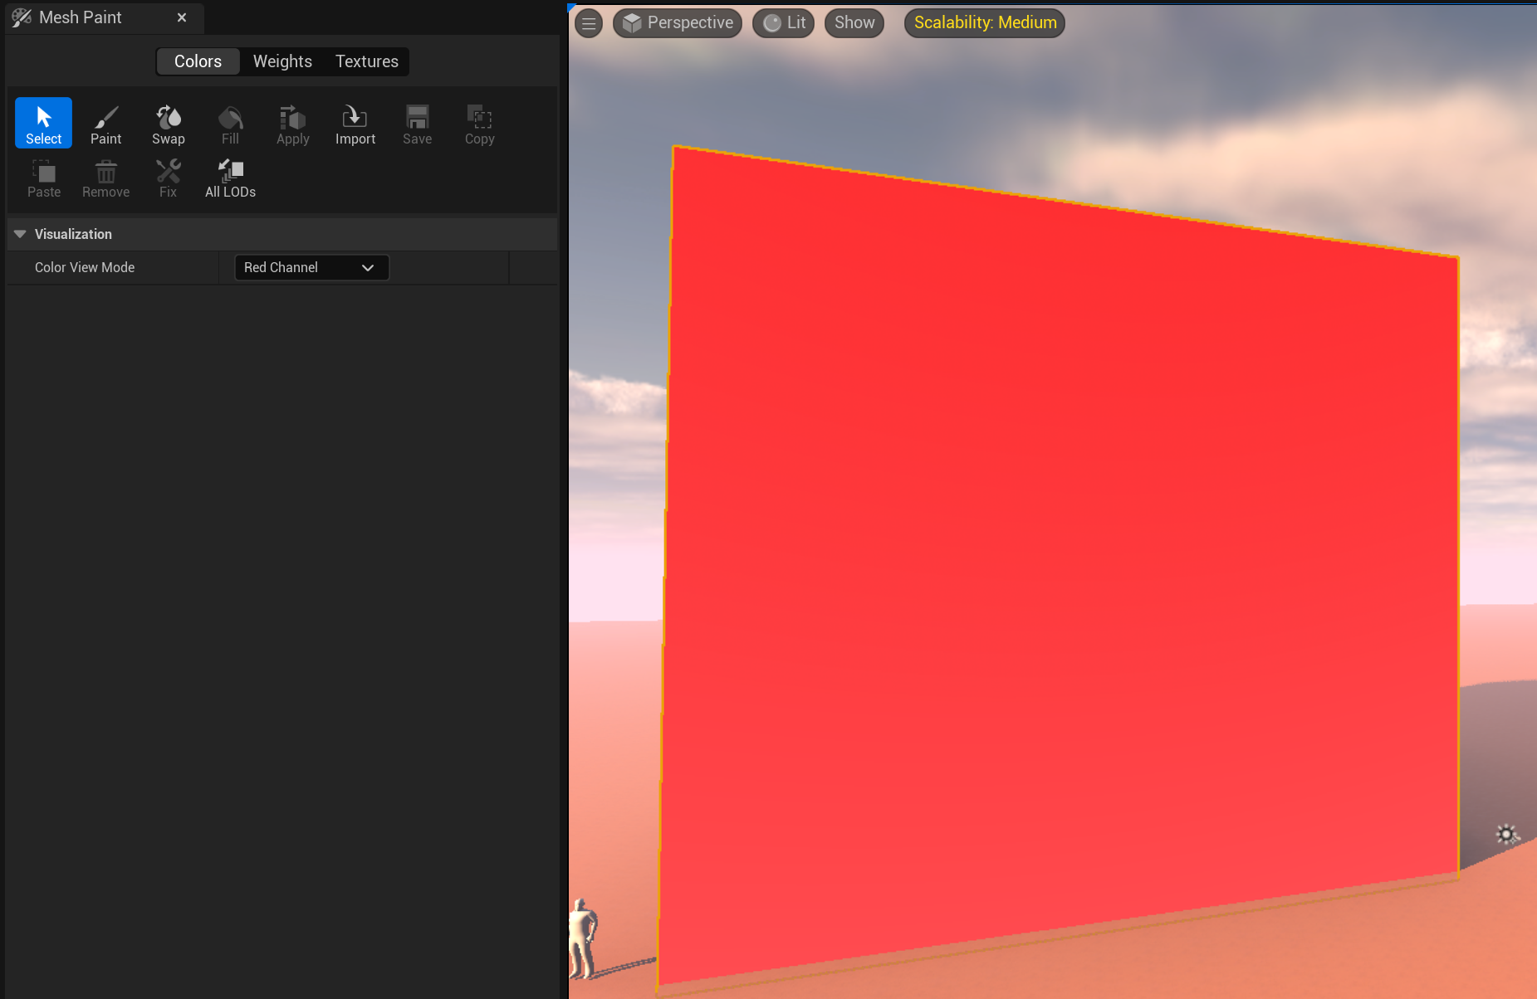

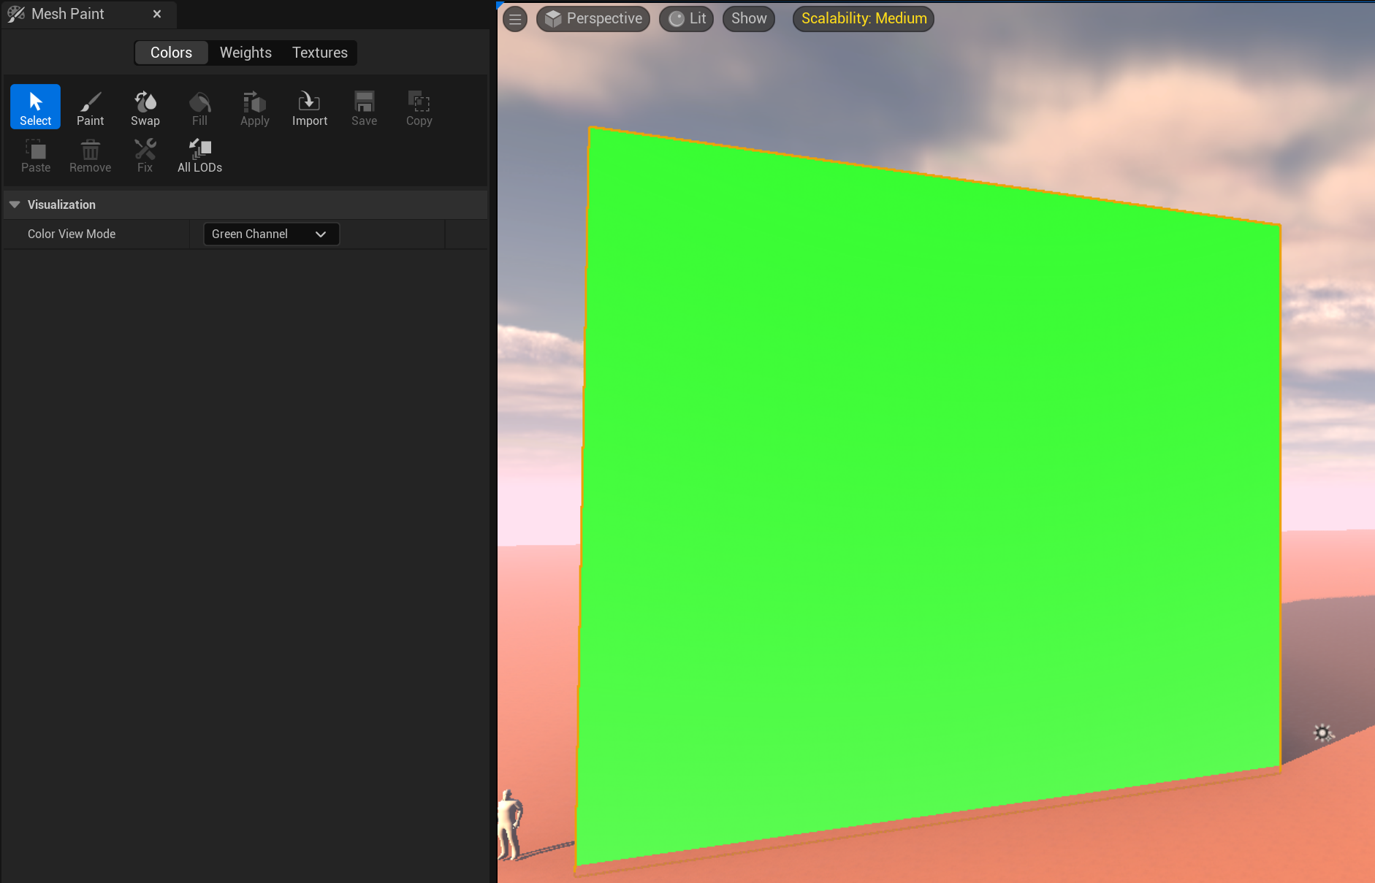

Both channels have 1 in them, hence the red and green colours respectively, and hence the blue brick being shown on the mesh. Let’s first clear all the channels.

We start by clearing all the channels

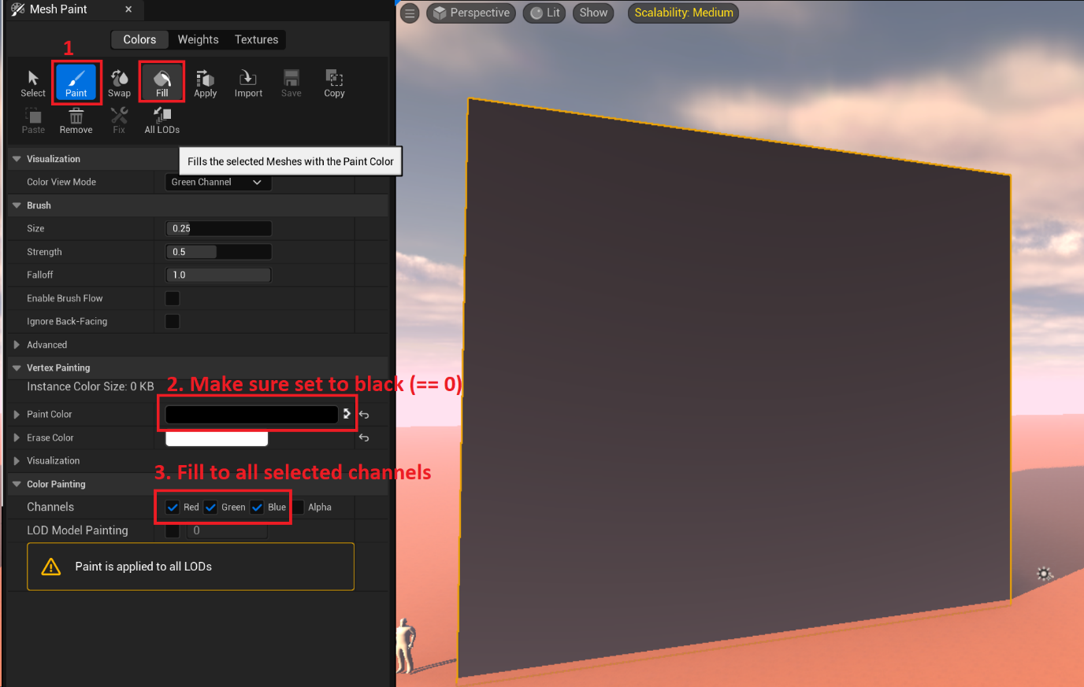

After doing this, select color view mode “off” and the cube should look as below (non-blue wall variation 1):

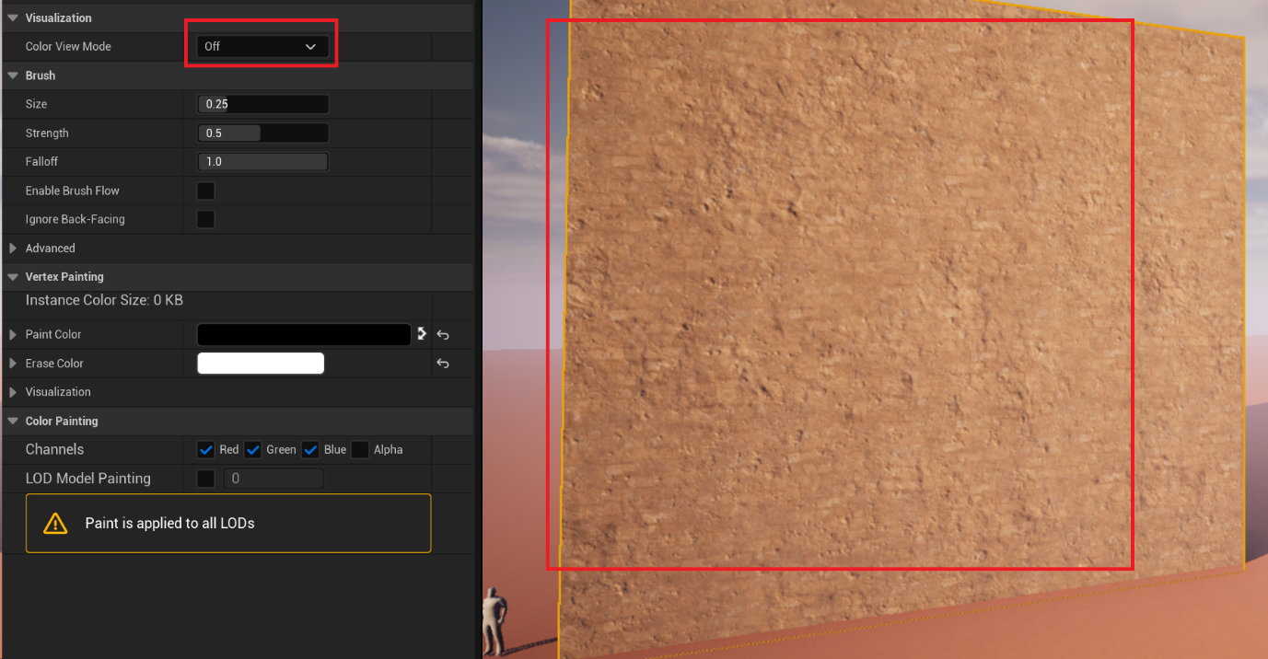

Then we can start painting in the largescale variation of material in this cube, painting white into the green channel to paint in the blue material, and black to remove the blue material.

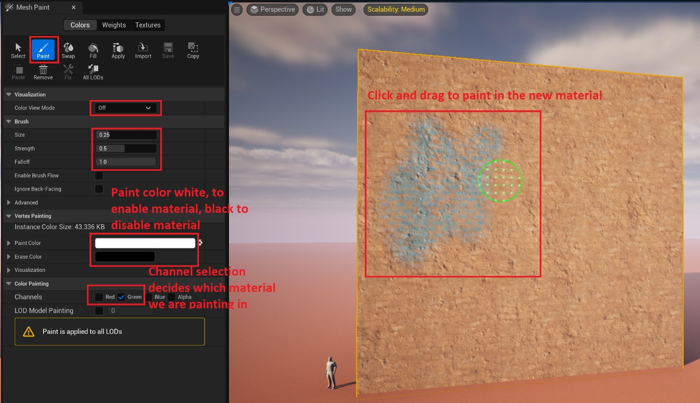

Painting white into the red channel paints in the second non-blue variation of the wall.

After carefully vertex painting the wall, there isn’t hardly any visible tiling anymore: 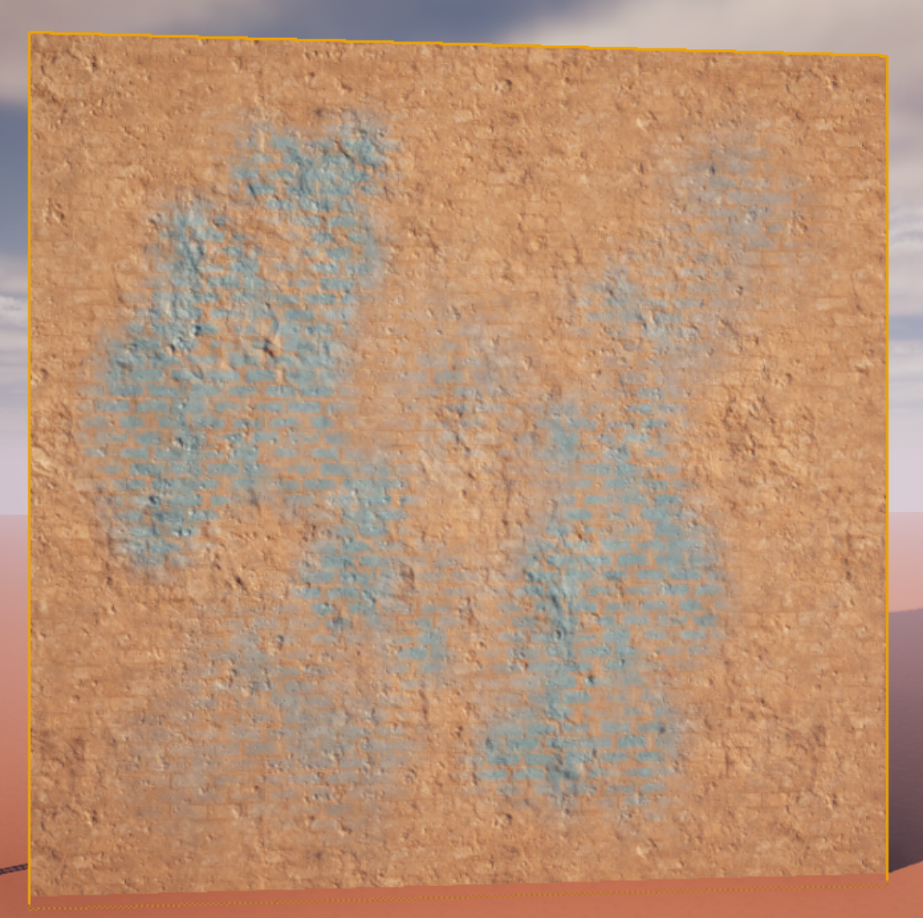

Compared to the version without vertex painting:



Looking at the colour channels we see the result of our vertex painting as well:

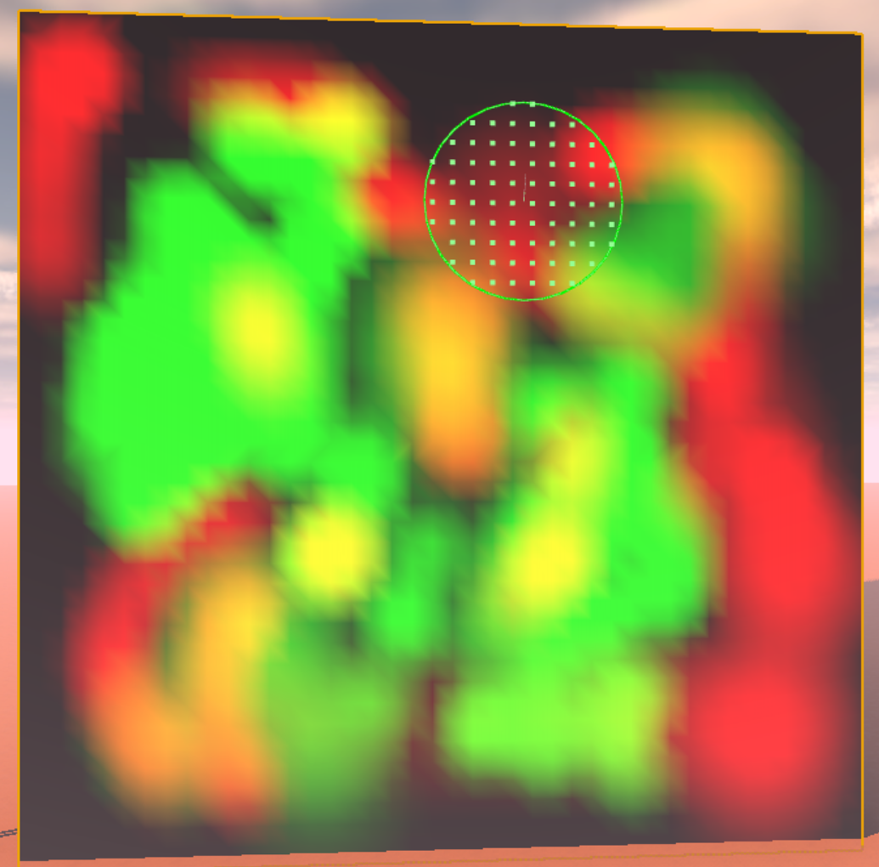

# Sharing ‘Merged Assets’

By sharing assets we can use our modular elements and built slightly complexer structures. E.g. a small temple, an exquisitely ornate, large pillar, a bridge, a long wide stair with railings, a round temple, whatever you can think off. Even using the modular building blocks, constructing a large environment can take a long time of fiddling with the right blocks and positioning them ‘just so’.

By making slightly larger blocks and sharing them with teammates/friends/enemies or just… plain colleagues, we can build a bigger environments by not having to build every compound asset from our base modular elements.

Let’s see how this can be done.

Suppose we wish to share the following “compound asset”, which is a two-arch wide bridge part, with railings on top.

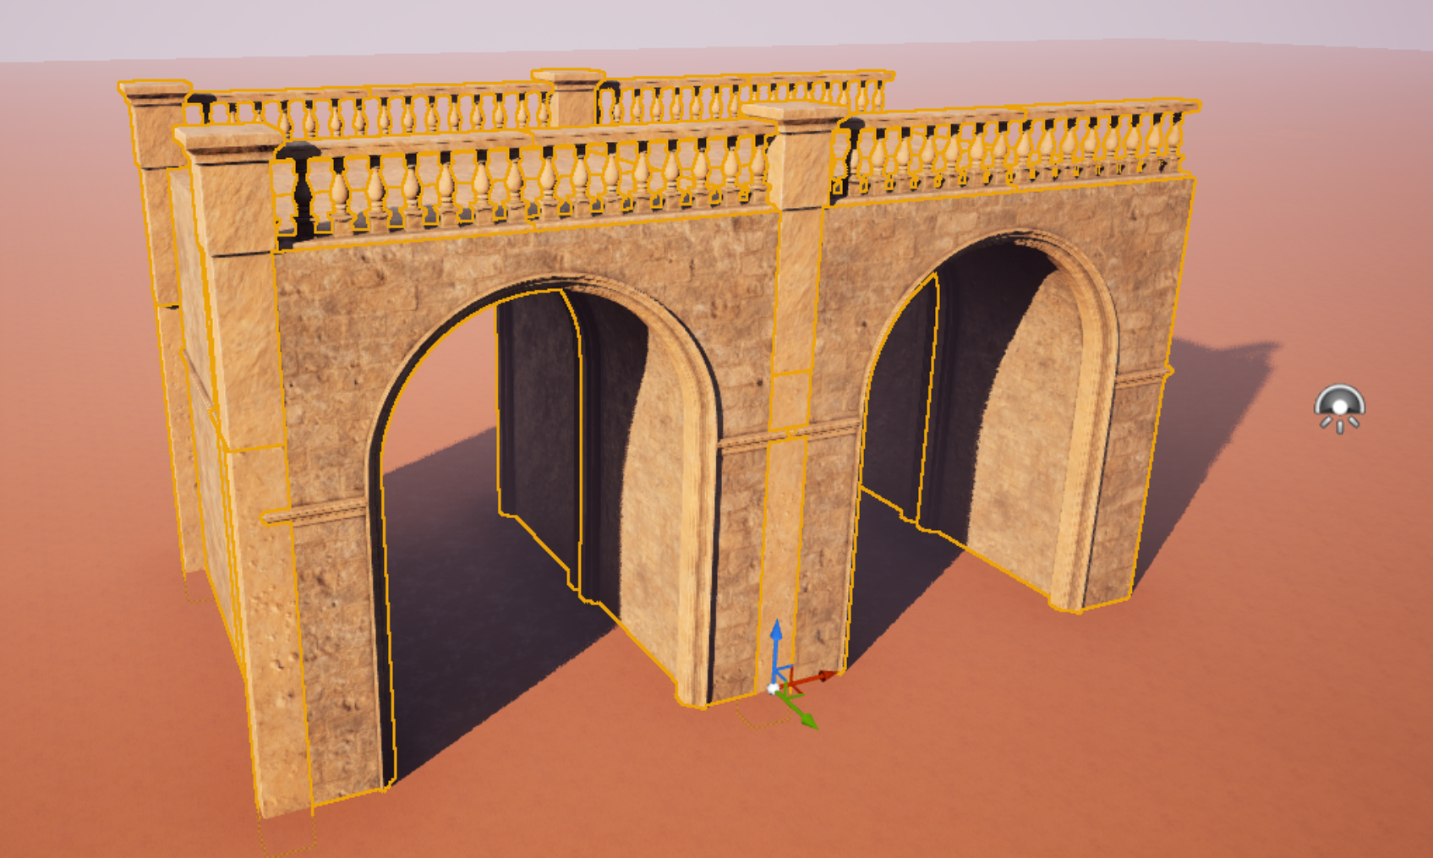

With all elements of our construction selected, we select **Tools > Merge actors.** Important, to make sure you have selected everything, and not too much, you can always click the “eye” in the Outliner, to see if anything remains visible, or disappears too much when hiding the combined selection.

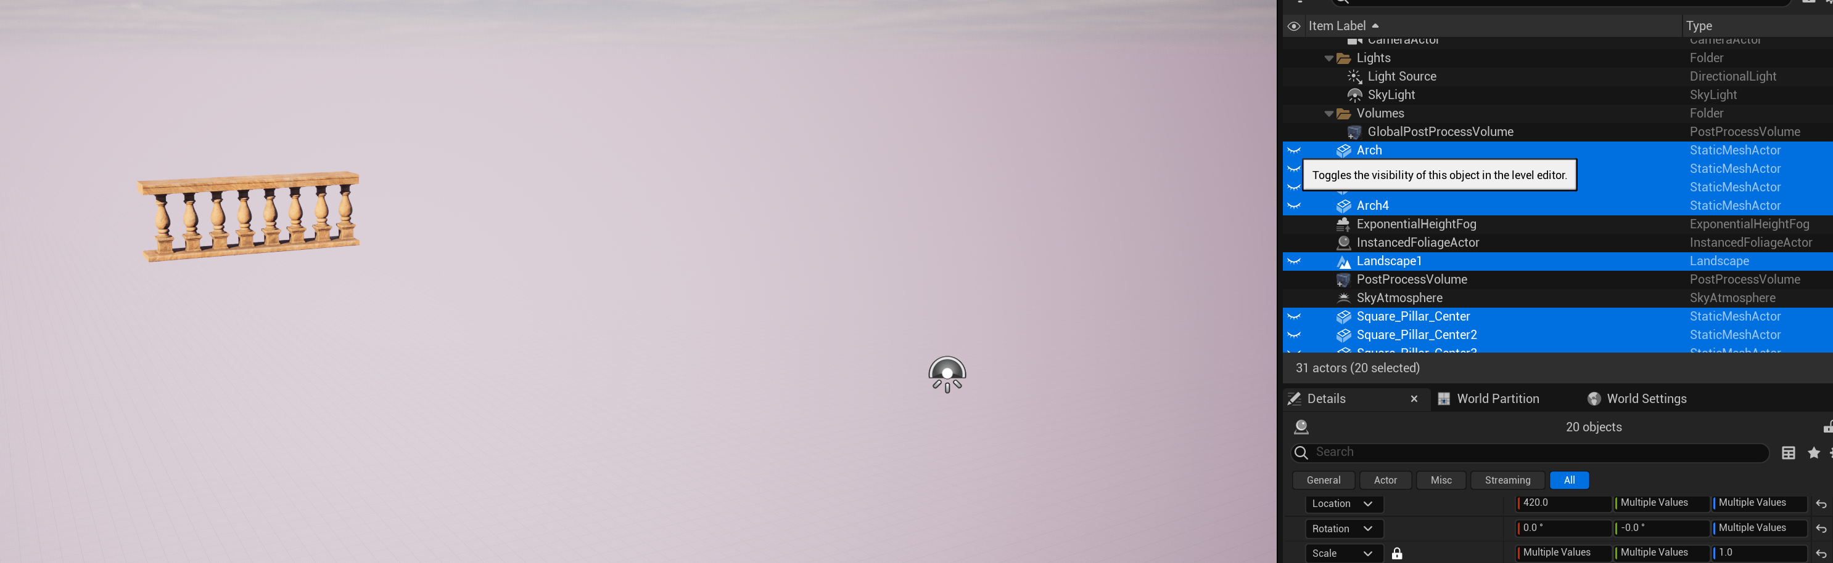

In this example we selected the landscape as well (oops), and forgot to select one part of the railing. Unhide everything and fix your selection. With the correct selection open the “Merge Actors” dialog.

Leave the merge method on **Merge**, and then click **Merge Actors.**

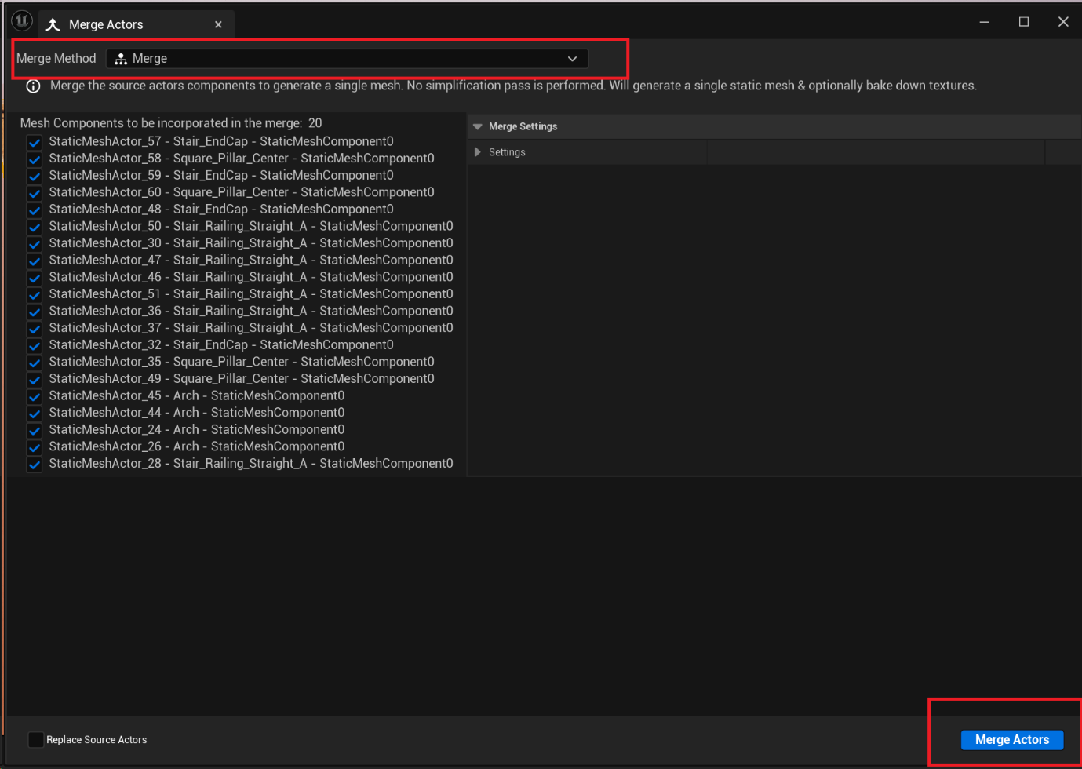

Select the **MergedAssets** folder, and give a descriptive name of your static mesh. E.g. “BridgeWithRailings”.

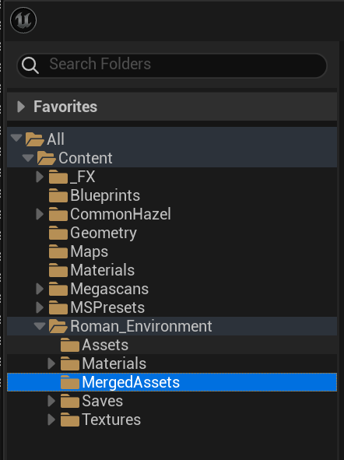

Afterwards, you can optionally remove the components in the outliner/level editor, and drag in the created merged asset. Or, you can keep the components as well, your choice.

**IMPORTANT**.

After creating a static mesh we lost a great deal of efficiency, namely our precalculated LOD’s (Level of Detail) settings. If we do not calculate new LOD’s for this merged asset and use too much of it in our scene, or if the merged asset is too large in and off itself, our performance will be hampered!

Let’s create new LOD’s for our static mesh.

1. Double click our merged asset static mesh. The window with static mesh properties opens: 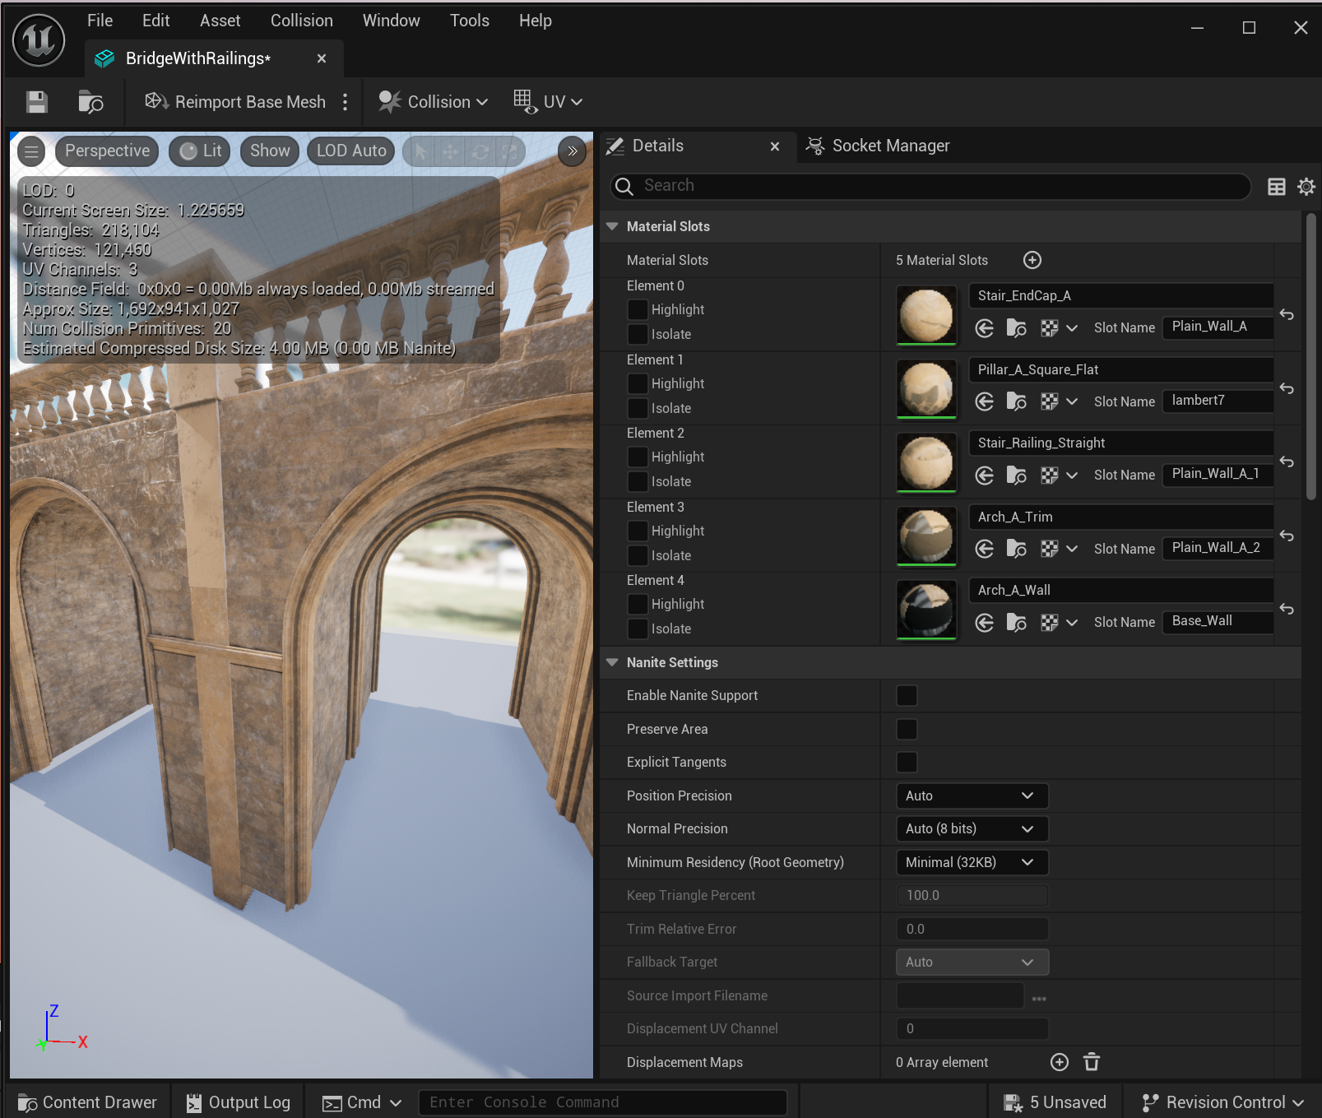
2. In the property window on the right we scroll down to “LOD Settings” and select “LevelArchitecture” as LOD Group value. 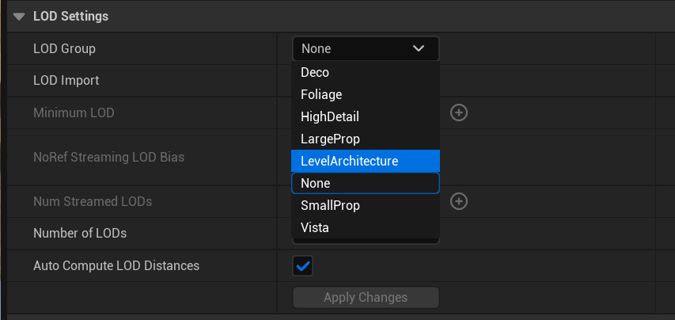
3. We get the warning that this will overwrite the LOD settings with the LOD settings of the LevelArchitecture group, we click YES. This is what we want.   
   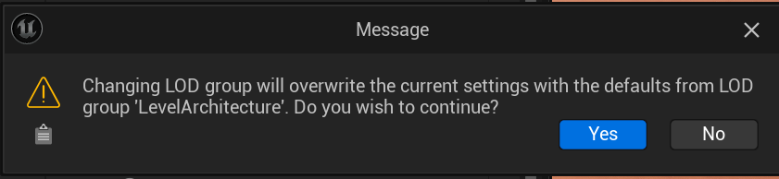
4. Now the LOD’s are being calculated. Note, depending on the size of your merged mesh this can take a long time (5+ minutes). After the calculation is completed, we can save our asset and it is now more optimized and better usable!   
   It is ready to be shared.

To share the merged asset, simply go to the MergedAssets folder in windows explorer, locate the .uasset file and share with someone else who places the file in their own MergedAssets folder.

**NOTE:** Do not move modular assets out of their current folders, nor materials, nor rename them. This might break the link between the merged asset and the instances it still references.

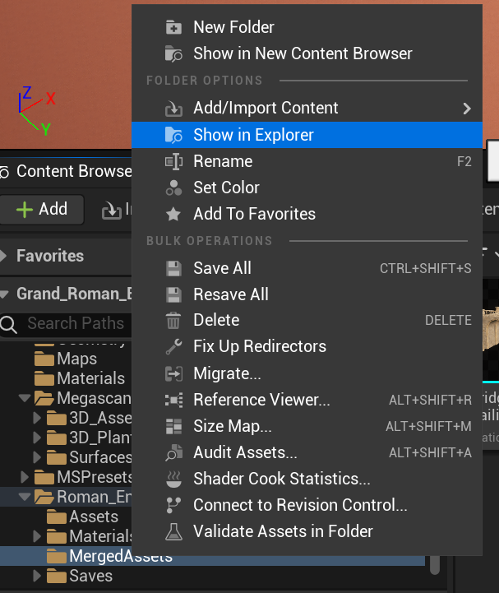

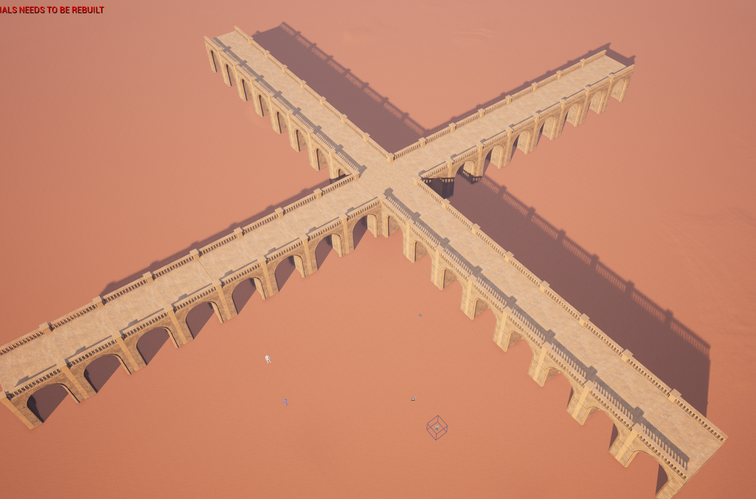

# Landscape Sculpting

A flat landscape is dull and uninviting. Giving some variation to our landscape adds a lot of life to our scene. Here we will go over the landscape sculpting tools. Select the landscape editing mode:

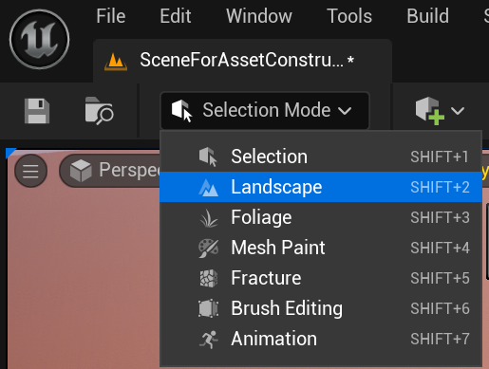

The landscape mode has a few sculpting tools that are fun to use. Sculpting can add or detract height from the landscape. Smoothing smooths out harsh edges, and makes the entire area softer. If you want to flatten something use the flatten tool and you can also use noise tool to just add some noise and interesting visual data to your landscape.

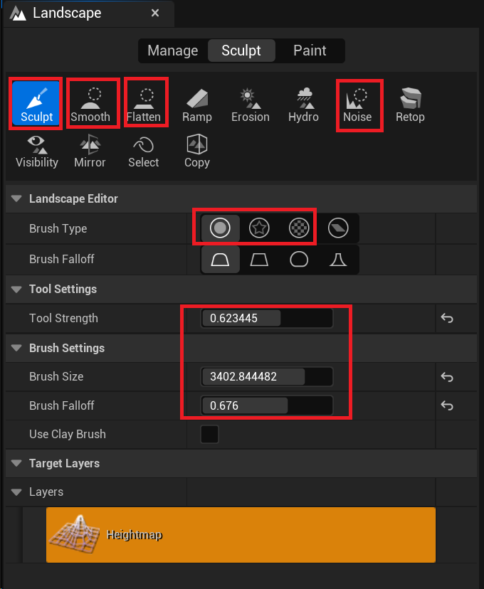

Note that the first Brush Type (Simple circular brush) is always a good one to use. The area below can be used to change the size of your brush, the strength of how much you want to raise the landscape per click or stroke (or lower the landscape when holding shift while clicking)., and the Brush falloff determines how much softer the strength of the brush becomes towards the outer edges of the brush.

Selecting the **Pattern Brush** brush type is a good choice to create some wavy sand patterns in the landscape. By default in this template project, it has a texture assigned that mimics sand waves well.

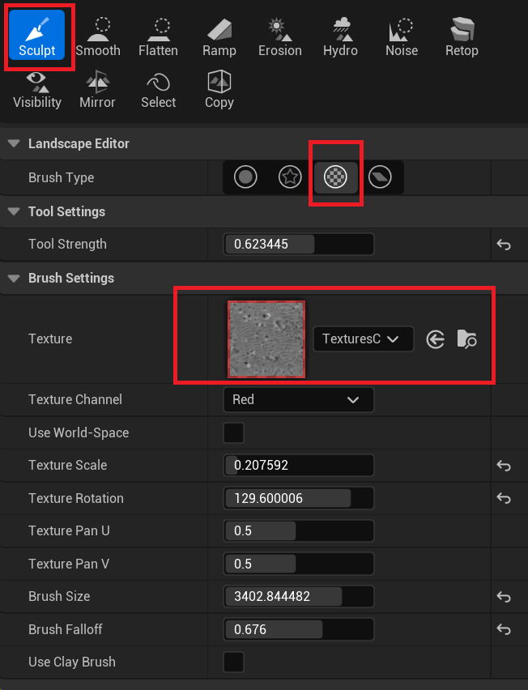

It is perfectly fine to make the terrain intersect with the geometry that is in your level.

